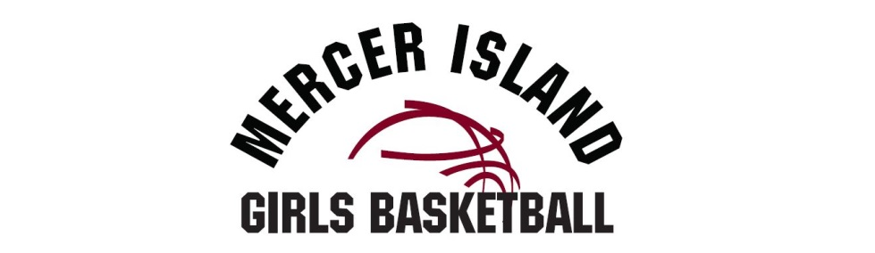

MIGB Covid Safety Protocol

All MIGB Participants and their families are responsible for keeping abreast of Washington State’s Department of Health guidelines and recommendations relating to Covid.

• All participants, adults and youth, must wear a face mask/covering unless engaged in physical activity • PPE will be provided by the participants
• No spectators or visitors allowed to minimize exposure risk.
• Parent Drop-Off and Pick-up ONLY!
• Hand Sanitizing stations or individual hand sanitizers for participants will be available for use.
• Wellness screenings, including temperature checks, of each individual must be taken upon entry to the facility (These will be performed by Peak staff)
o Participants who present a temperature over 100.4, have upper respiratory
issues such as coughing, or symptom of any illness will be sent home.
• Participants are responsible for notifying MIGB immediately if any person participating in our MIGB program has tested positive for COVID-19.
• Physical distancing practices, of 6 feet, will be maintained among athletes when not engaged in sporting activities.
• Huddles/team meetings must be physically distanced and unnecessary physical contact such as high fives, handshakes, fist bumps or hugs are discouraged.
• Doors will be kept open to ventilate the gymnasium better.
• Drinking fountains are closed, participants must provide their own water.

